**MyDamco URL Verification**

**CSS LB VIP’s :**

We don’t see any issues on accessing application with existing LB IP’s. Please find below screen shot for the same:

**Production (193.163.252.20)**

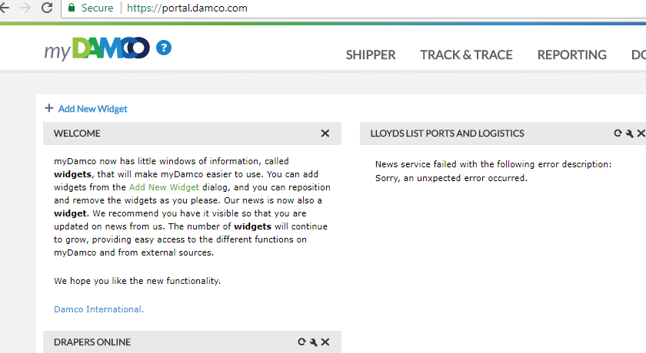

**Pre-Production (193.163.252.19)**

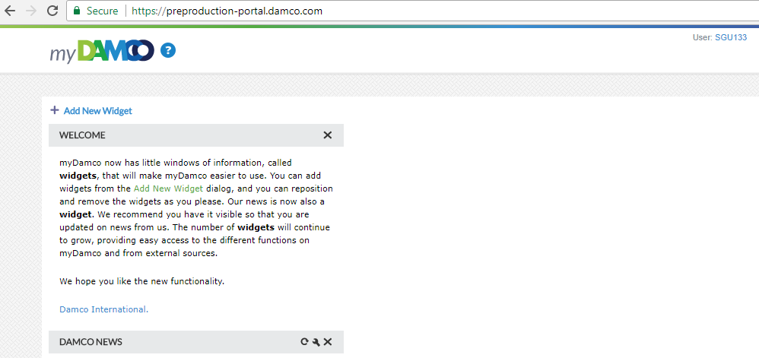

**Integration (193.163.252.18)**

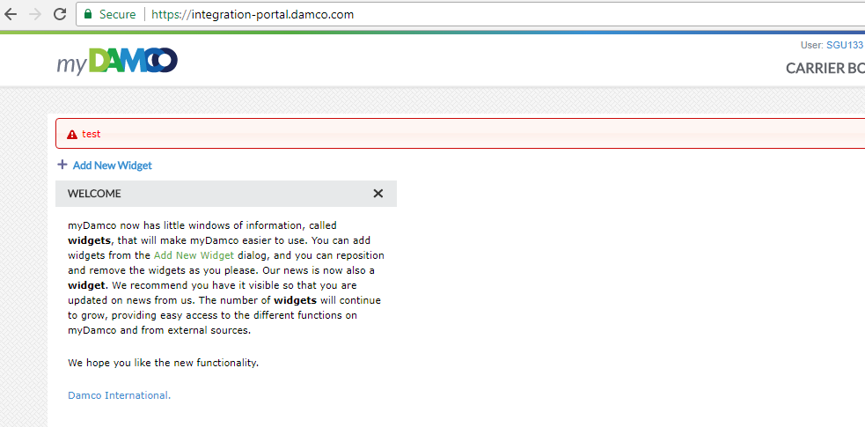

**F5 LB VIP**

We are unable access with new IP’s provided. Please find below screenshot for the same:

**Production (193.163.251.69)**

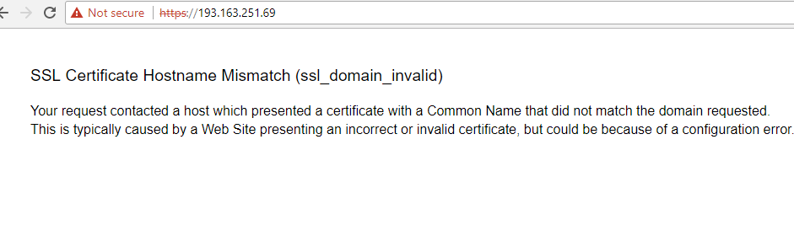

**Pre-Production (193.163.251.168)**

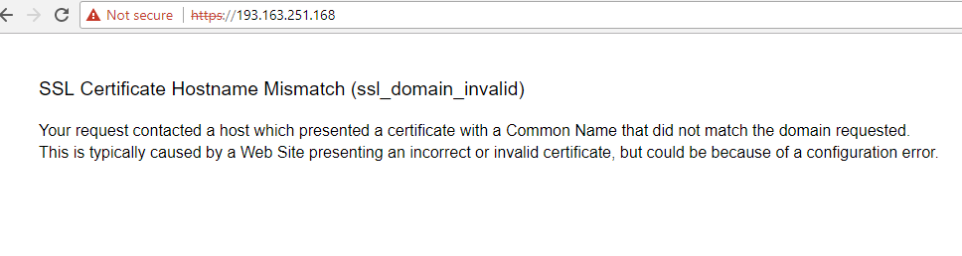

**Integration (193.163.251.224)**

